**WEEK 7 HANDSON -REACT**

**HandsOn 13 :**

**Task :**

**In this hands-on lab, you will learn how to:**

* **Implement conditional rendering in React applications**

**CODES AND OUTPUTS :**

**Step 1 :**

**Create a React App named “bloggerapp” in with 3 components.**

1. **Book Details**
2. **Blog Details**
3. **Course Details**

**Npx create-react-app bloggerapp**

**Cd bloggerapp**

**Npm start**

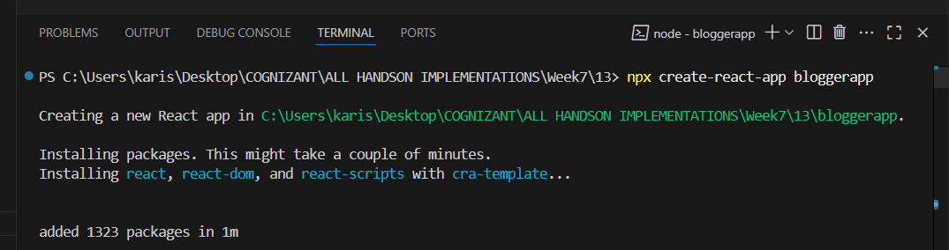

**Create 3 components :**

**BookDetails.js**

**BlogDetails.js**

**CourseDetails.js**

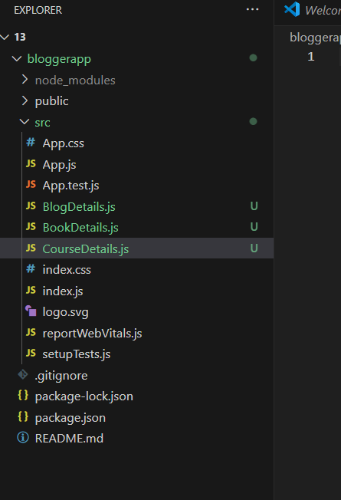

**Step 2 :**

**BookDetails.js :**

import React from "react";

function BookDetails() {

  return (

    <div>

      <h2>Book Details</h2>

      <p>Book: React in Action</p>

      <p>Author: Mark Tielens Thomas</p>

    </div>

  );

}

export default BookDetails;

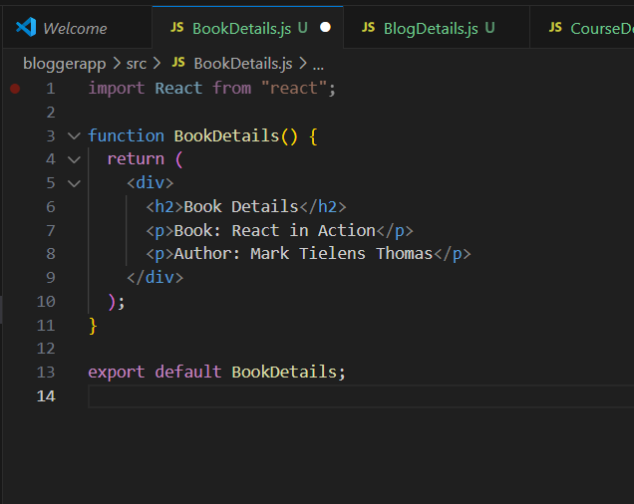

**BlogDetails.js :**

import React from "react";

function BlogDetails() {

return (

<div>

<h2>📝 Blog Details</h2>

<p>Blog Title: Mastering React Basics</p>

<p>Author: Sharmila Shaik</p>

</div>

);

}

export default BlogDetails;

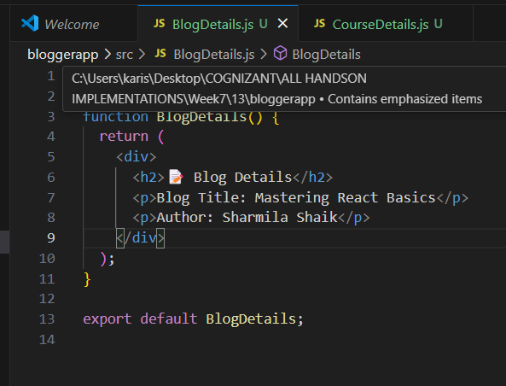

**CourseDetails.js :**

import React from "react";

function CourseDetails() {

  return (

    <div>

      <h2> Course Details</h2>

      <p>Course: Full Stack Development</p>

      <p>Platform: Coursera</p>

    </div>

  );

}

export default CourseDetails;

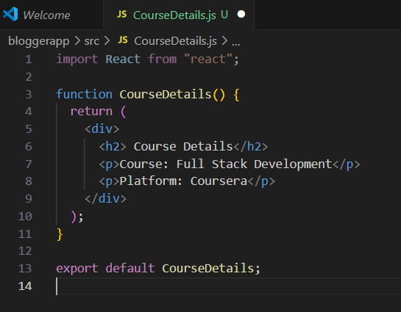

**App.js :**

import React from "react";

import CourseDetails from "./CourseDetails";

import BookDetails from "./BookDetails";

import BlogDetails from "./BlogDetails";

import "./App.css";

function App() {

  const courses = [

    { name: "Angular", date: "4/5/2021" },

    { name: "React", date: "6/3/20201" }

  ];

  const books = [

    { id: 1, bname: "Master React", price: 670 },

    { id: 2, bname: "Deep Dive into Angular 11", price: 800 },

    { id: 3, bname: "Mongo Essentials", price: 450 }

  ];

  const blogs = [

    { title: "React Learning", author: "Stephen Biz", content: "Welcome to learning React!" },

    { title: "Installation", author: "Schwezdenier", content: "You can install React from npm." }

  ];

  return (

    <div className="container">

      <div className="section">

        <h1>Course Details</h1>

        <CourseDetails courses={courses} />

      </div>

      <div className="section">

        <h1>Book Details</h1>

        <BookDetails books={books} />

      </div>

      <div className="section">

        <h1>Blog Details</h1>

        <BlogDetails blogs={blogs} />

      </div>

    </div>

  );

}

export default App;

**App.css :**

.container {

  display: flex;

  justify-content: space-around;

  padding: 20px;

  font-family: Arial;

  text-align: left;

}

.section {

  border-left: 4px solid green;

  padding-left: 20px;

  width: 30%;

}

FINAL OUTPUT :

